Net in Solid Geometry

Definition
# Source: AI Source: Provided by: [Data Path: Persons Table -> ID Column: 1, Name_En Column: Motasem Essam] -> From: [ChatGPT] on [7/25/2026]
A net in solid geometry is a two-dimensional arrangement of flat shapes that can be folded along their edges to form the surface of a three-dimensional solid.
A net shows the faces of a solid laid flat in a plane. When folded correctly, the shapes meet along their corresponding edges to create the solid's surface.
For example, a cube net consists of six squares arranged so that they can fold together to form a cube.
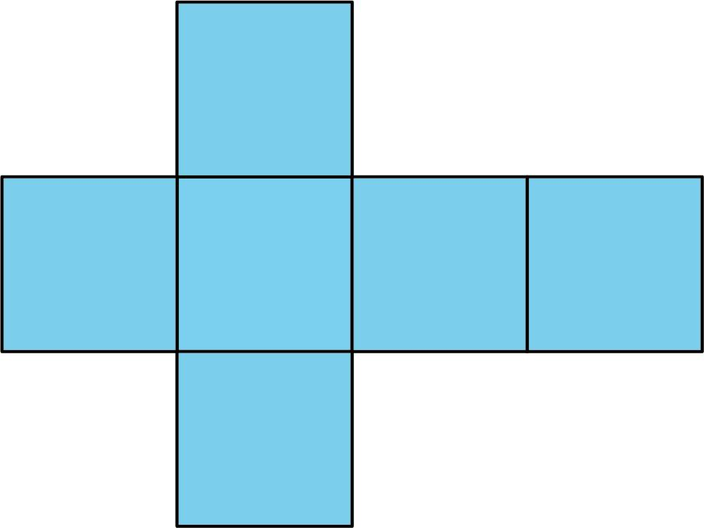
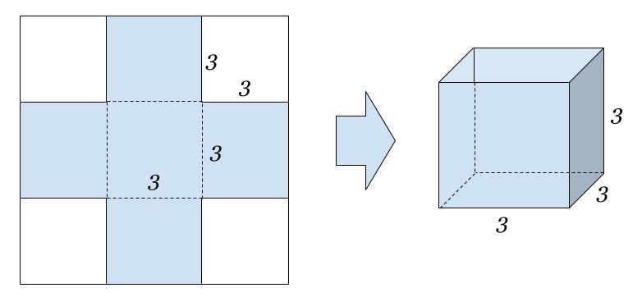
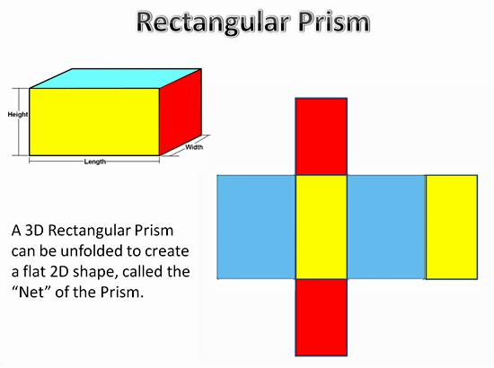

Simple Definition
# Source: AI Source: Provided by: [Data Path: Persons Table -> ID Column: 1, Name_En Column: Motasem Essam] -> From: [ChatGPT] on [7/25/2026]
A net is a flat pattern that can be folded to make a three-dimensional solid.
Examples:
- Six connected squares can form a cube.
- Six rectangles can form a rectangular prism, provided their dimensions and arrangement are compatible.
- One square and four triangles can form a square pyramid.
- One circular sector and one circle can form the lateral surface and base of a right circular cone, with the sector's arc length matching the circle's circumference.
A net represents the surface of a solid unfolded onto a plane; it does not represent the solid's volume.

Classification Tree
# Source: AI Source: Provided by: [Data Path: Persons Table -> ID Column: 1, Name_En Column: Motasem Essam] -> From: [ChatGPT] on [7/25/2026]
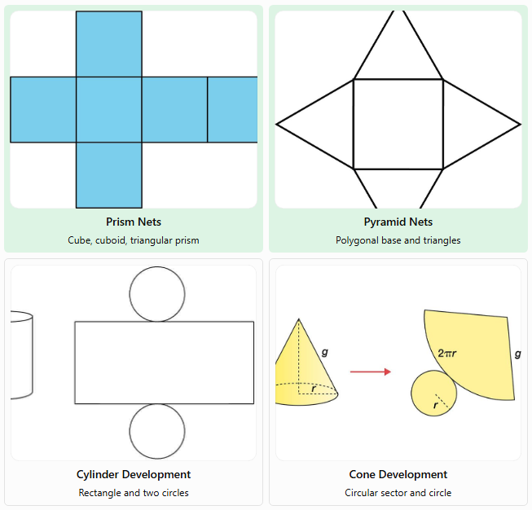
Prism Nets
Cube, cuboid, triangular prism
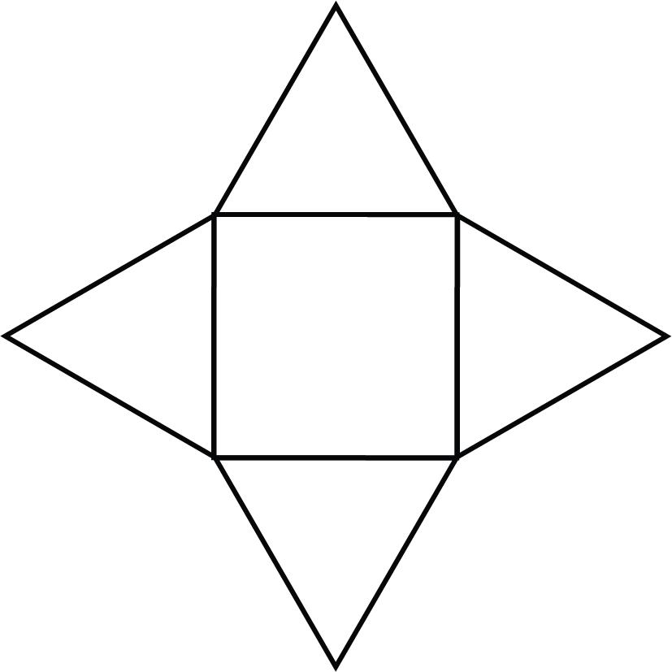
Pyramid Nets
Polygonal base and triangles
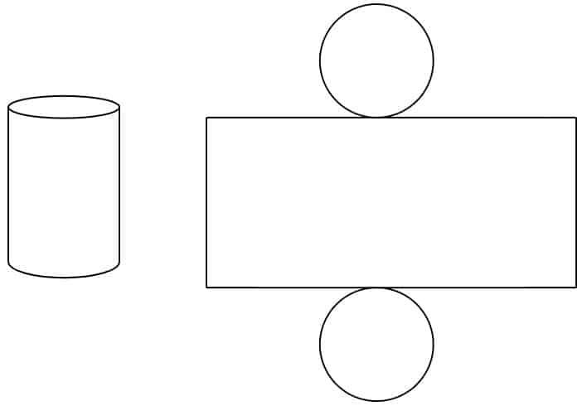
Cylinder Development
Rectangle and two circles
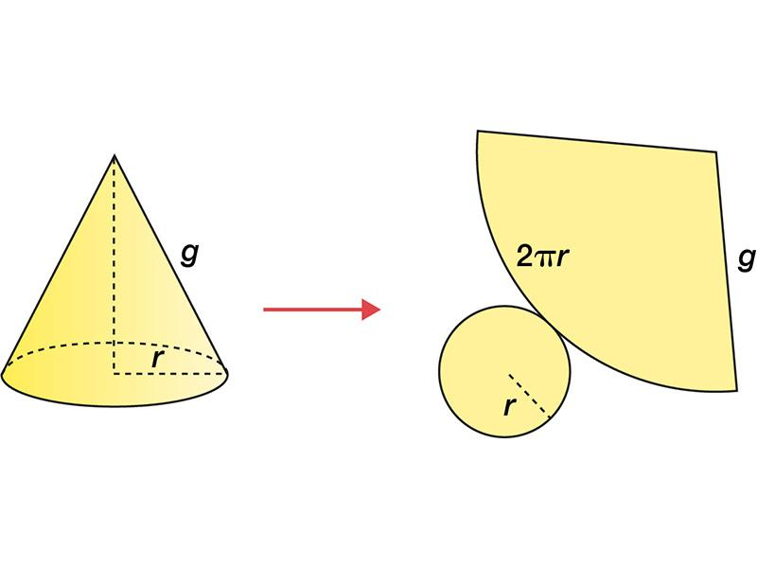
Cone Development
Circular sector and circle
Strictly speaking, nets of polyhedra are made of connected polygons. For curved solids such as cylinders and cones, the unfolded surface includes curved-surface developments, which are flat regions bounded by straight or curved lines.

Key Characteristics of a Net
# Source: AI Source: Provided by: [Data Path: Persons Table -> ID Column: 1, Name_En Column: Motasem Essam] -> From: [ChatGPT] on [7/25/2026]
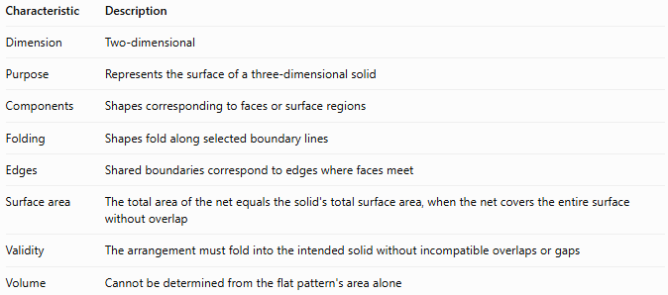
Characteristic | Description
Dimension | Two-dimensional
Purpose | Represents the surface of a three-dimensional solid
Components | Shapes corresponding to faces or surface regions
Folding | Shapes fold along selected boundary lines
Edges | Shared boundaries correspond to edges where faces meet
Surface area | The total area of the net equals the solid's total surface area, when the net covers the entire surface without overlap
Validity | The arrangement must fold into the intended solid without incompatible overlaps or gaps
Volume | Cannot be determined from the flat pattern's area alone
A valid net must have the correct shapes and dimensions and a compatible arrangement. Having the correct number of faces is necessary but not always sufficient.

Geometric Representation of Common Nets

A. Net of a cube
# Source: AI Source: Provided by: [Data Path: Persons Table -> ID Column: 1, Name_En Column: Motasem Essam] -> From: [ChatGPT] on [7/25/2026]
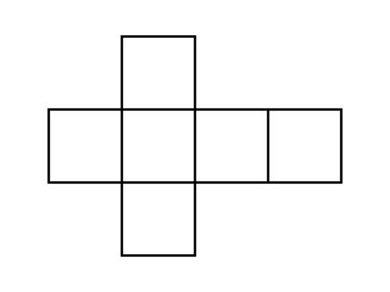
A cube has six congruent square faces. A valid cube net arranges six squares so they can fold into the six faces of a cube.
Properties:
- Number of faces: $F=6$
- Shape of each face: square
- Number of edges: $E=12$
- Number of vertices: $V=8$
A cube has 11 distinct nets when rotations and reflections are not counted as different arrangements.

B. Net of a rectangular prism
# Source: AI Source: Provided by: [Data Path: Persons Table -> ID Column: 1, Name_En Column: Motasem Essam] -> From: [ChatGPT] on [7/25/2026]
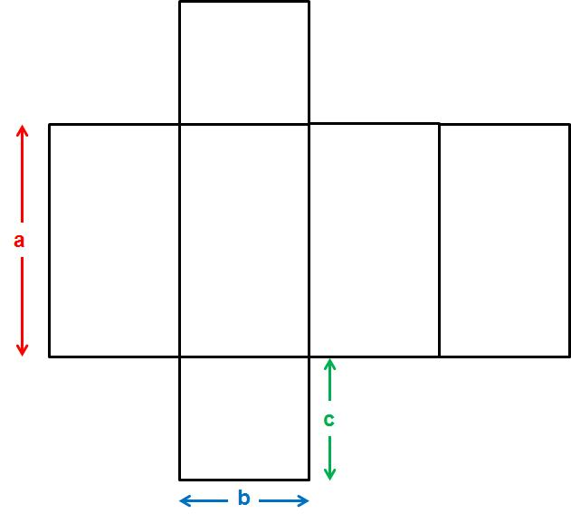
A rectangular prism has six rectangular faces. Opposite faces have equal dimensions, and the net must place the rectangles so their shared edges match when folded.
For a prism with length $l$, width $w$, and height $h$, the net contains:
- Two rectangles of dimensions $l×w$.
- Two rectangles of dimensions $l×h$.
- Two rectangles of dimensions $w×h$.

C. Net of a square pyramid
# Source: AI Source: Provided by: [Data Path: Persons Table -> ID Column: 1, Name_En Column: Motasem Essam] -> From: [ChatGPT] on [7/25/2026]
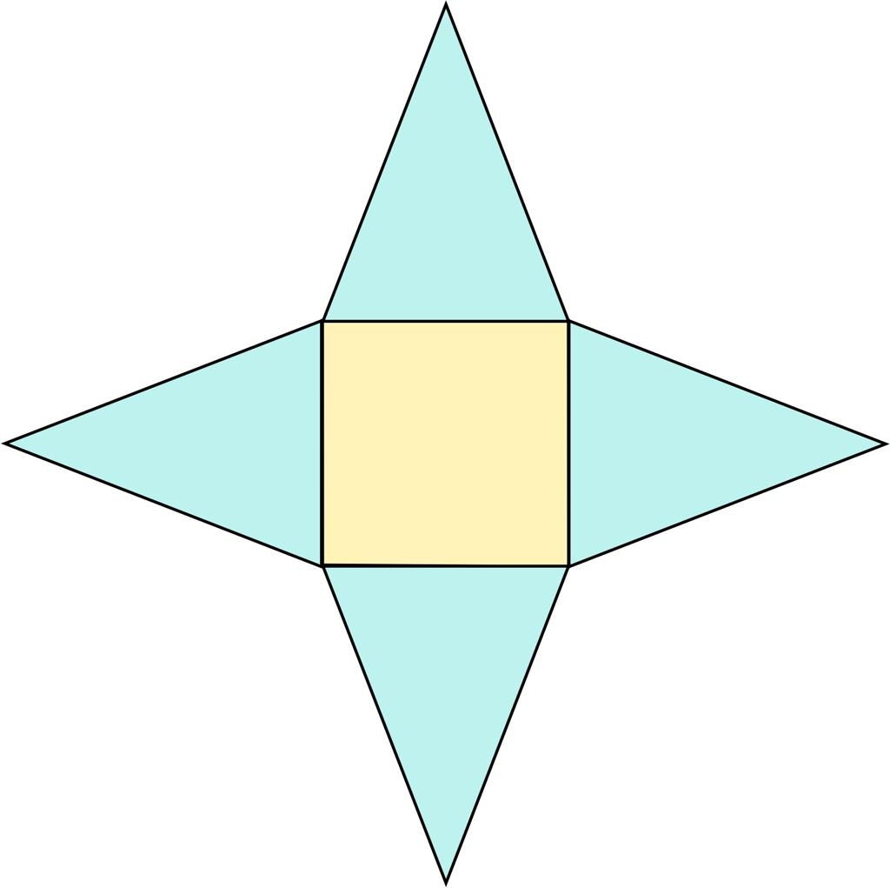
A square pyramid's net consists of one square base and four triangular lateral faces.
When folded, the four triangles meet at the apex.

D. Net of a triangular prism
# Source: AI Source: Provided by: [Data Path: Persons Table -> ID Column: 1, Name_En Column: Motasem Essam] -> From: [ChatGPT] on [7/25/2026]
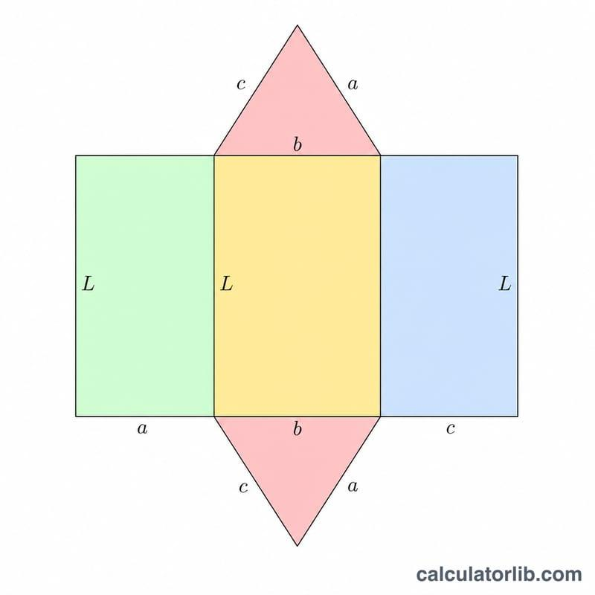
A triangular prism has five faces: two congruent triangular bases and three lateral faces. Its net contains these five regions arranged so that the triangles and rectangles meet along matching edges.

E. Net of a cylinder
# Source: AI Source: Provided by: [Data Path: Persons Table -> ID Column: 1, Name_En Column: Motasem Essam] -> From: [ChatGPT] on [7/25/2026]
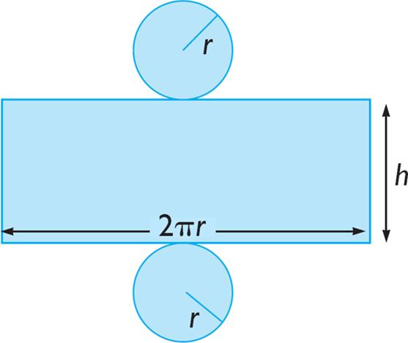
The complete surface development of a right circular cylinder contains one rectangle and two equal circles.
- Rectangle width: cylinder height $h$.
- Rectangle length: circumference of the base, $2πr$.
- Two circles: the top and bottom bases.
The rectangle wraps around to form the curved lateral surface.

F. Net of a cone
# Source: AI Source: Provided by: [Data Path: Persons Table -> ID Column: 1, Name_En Column: Motasem Essam] -> From: [ChatGPT] on [7/25/2026]
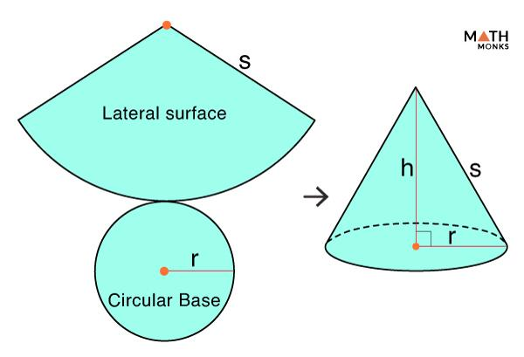
The complete surface development of a right circular cone consists of one circular base and one circular sector representing its curved lateral surface.
The sector's radius is the cone's slant height $l$, and its arc length must equal the circumference of the base, $2πr$.

Mathematical Representation and Formulas

A. Surface area from a net
The total surface area of a solid equals the sum of the areas of all regions in its complete net:
$$SA=\sum_{i=1}^{m}{A_{i}}$$
where $A_{i}$ is the area of each face or surface region, and $m$ is the number of regions in the net.

B. Cube
# Source: AI Source: Provided by: [Data Path: Persons Table -> ID Column: 1, Name_En Column: Motasem Essam] -> From: [ChatGPT] on [7/25/2026]
For a cube with side length $s$, all six faces are squares:
$$SA=6s^{2}$$

C. Rectangular prism
# Source: AI Source: Provided by: [Data Path: Persons Table -> ID Column: 1, Name_En Column: Motasem Essam] -> From: [ChatGPT] on [7/25/2026]
For a rectangular prism with length $l$, width $w$, and height $h$:
$$SA=2\left(lw+lh+wh\right)$$

D. Square pyramid
# Source: AI Source: Provided by: [Data Path: Persons Table -> ID Column: 1, Name_En Column: Motasem Essam] -> From: [ChatGPT] on [7/25/2026]
For a square pyramid with base side length $s$ and slant height $l$:
$$SA=s^{2}+4\left(\frac{12}{s}l\right)$$
Simplifying:
$$SA=s^{2}+2sl$$
This formula assumes a square base and four triangular lateral faces with the same slant height, as in a regular right square pyramid.

E. Cylinder
# Source: AI Source: Provided by: [Data Path: Persons Table -> ID Column: 1, Name_En Column: Motasem Essam] -> From: [ChatGPT] on [7/25/2026]
For a right circular cylinder with radius $r$ and height $h$:
$$SA=2πr^{2}+2πrh$$
The first term is the area of the two circular bases, and the second is the area of the rectangular development of the curved surface.

F. Cone
# Source: AI Source: Provided by: [Data Path: Persons Table -> ID Column: 1, Name_En Column: Motasem Essam] -> From: [ChatGPT] on [7/25/2026]
For a right circular cone with radius $r$ and slant height $l$:
$$SA=πr^{2}+πrl$$
The first term is the circular base, and the second is the area of the sector forming the lateral surface.

Worked Examples
# Source: AI Source: Provided by: [Data Path: Persons Table -> ID Column: 1, Name_En Column: Motasem Essam] -> From: [ChatGPT] on [7/25/2026]
Example 1: Finding the surface area from a cube net
A cube net consists of six squares, each with side length $4\text{ cm}$. Find the total surface area of the cube.
Step 1: Find the area of one square.
$$A=s^{2}=4^{2}=16{\text{ cm}}^{2}$$
Step 2: Add the areas of all six squares.
$$SA=6\left(16\right)=96{\text{ cm}}^{2}$$
Answer: The cube's total surface area is $96{\text{ cm}}^{2}$.
Example 2: Finding the surface area of a rectangular prism
A rectangular prism has dimensions $8\text{ cm}$, $5\text{ cm}$, and $3\text{ cm}$. Find its surface area using the faces shown in its net.
The six rectangles occur in three equal pairs:
$$\begin{aligned}A_{1}&=2\left(8×5\right)=80 \\ A_{2}&=2\left(8×3\right)=48 \\ A_{3}&=2\left(5×3\right)=30\end{aligned}$$
Adding the areas gives
$$SA=80+48+30=158{\text{ cm}}^{2}$$
Answer: The total surface area is $158{\text{ cm}}^{2}$.
Example 3: Finding the surface area of a square pyramid
A regular square pyramid has a base side length of $6\text{ cm}$ and a slant height of $5\text{ cm}$. Calculate its total surface area from its net.
Step 1: Calculate the square base area.
$$A_{\text{base}}=6^{2}=36{\text{ cm}}^{2}$$
Step 2: Calculate the area of one triangular face.
$$A_{\text{triangle}}=\frac{12}{\left(6\right)}\left(5\right)=15{\text{ cm}}^{2}$$
Step 3: Add the four triangular faces and the base.
$$SA=36+4\left(15\right)=96{\text{ cm}}^{2}$$
Answer: The total surface area is $96{\text{ cm}}^{2}$.
Example 4: Finding the surface area of a cylinder from its development
A cylinder has radius $3\text{ cm}$ and height $7\text{ cm}$.
Its net contains a rectangle and two circles.
The rectangle's dimensions are $7\text{ cm}$ by $2π\left(3\right)=6π\text{ cm}$, so its area is
$$A_{\text{rectangle}}=7\left(6π\right)=42π{\text{ cm}}^{2}$$
The two circular bases have combined area
$$A_{\text{circles}}=2π{\left(3\right)}^{2}=18π{\text{ cm}}^{2}$$
Therefore,
$$SA=42π+18π=60π{\text{ cm}}^{2}$$
$$SA≈188.50{\text{ cm}}^{2}$$
Answer: The total surface area is $60π{\text{ cm}}^{2}$, approximately $188.50{\text{ cm}}^{2}$.

Comparison with Related Concepts
# Source: AI Source: Provided by: [Data Path: Persons Table -> ID Column: 1, Name_En Column: Motasem Essam] -> From: [ChatGPT] on [7/25/2026]
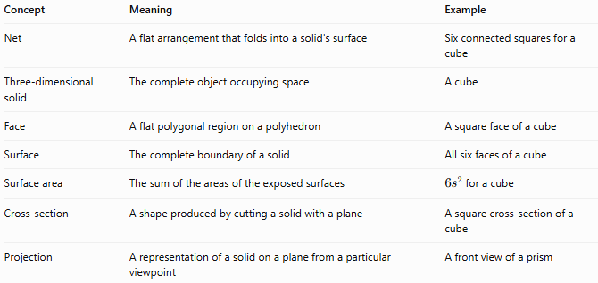
Concept | Meaning | Example
Net | A flat arrangement that folds into a solid's surface | Six connected squares for a cube
Three-dimensional solid | The complete object occupying space | A cube
Face | A flat polygonal region on a polyhedron | A square face of a cube
Surface | The complete boundary of a solid | All six faces of a cube
Surface area | The sum of the areas of the exposed surfaces | $6s^{2}$ for a cube
Cross-section | A shape produced by cutting a solid with a plane | A square cross-section of a cube
Projection | A representation of a solid on a plane from a particular viewpoint | A front view of a prism
Important distinction: A net shows the solid's surface unfolded, while a cross-section shows a slice through the solid. Neither should be confused with the solid itself.

Properties of a Valid Net
# Source: AI Source: Provided by: [Data Path: Persons Table -> ID Column: 1, Name_En Column: Motasem Essam] -> From: [ChatGPT] on [7/25/2026]
A valid net must satisfy several conditions:
- Correct shapes: It must contain the faces or surface regions required by the intended solid.
- Matching edges: Edges that meet after folding must have compatible lengths.
- Compatible arrangement: The regions must fold into the intended configuration.
- No conflicting overlaps: The folded faces must not occupy incompatible positions.
- Complete surface: For a complete net, every part of the solid's surface must be represented.
A net can contain the correct number of shapes and still be invalid if those shapes are arranged incorrectly.

Applications of Nets in Solid Geometry
# Source: AI Source: Provided by: [Data Path: Persons Table -> ID Column: 1, Name_En Column: Motasem Essam] -> From: [ChatGPT] on [7/25/2026]
- Packaging: Designing cardboard boxes and cartons before cutting and folding.
- Manufacturing: Planning sheet materials for containers and enclosures.
- Architecture: Understanding how flat panels form three-dimensional structures.
- Education: Visualizing the relationship between two-dimensional shapes and three-dimensional solids.
- Computer-aided design: Unfolding surfaces to prepare patterns for fabrication.
- Surface-area calculations: Adding the areas of the unfolded regions without repeatedly visualizing the three-dimensional object.

Key Points
# Source: AI Source: Provided by: [Data Path: Persons Table -> ID Column: 1, Name_En Column: Motasem Essam] -> From: [ChatGPT] on [7/25/2026]
- A net is a two-dimensional representation of a solid's unfolded surface.
- Folding a valid net produces the surface of the intended three-dimensional solid.
- A cube net contains six squares.
- A square pyramid net contains one square and four triangular faces.
- A triangular prism net contains two triangles and three lateral faces.
- A cylinder's surface development contains a rectangle and two circles.
- A cone's surface development contains a circular sector and one circle.
- The total surface area equals the sum of the areas of the regions in a complete net.
- A net does not directly represent the solid's volume.
- Not every arrangement of the correct shapes is a valid net.

Conclusion
# Source: AI Source: Provided by: [Data Path: Persons Table -> ID Column: 1, Name_En Column: Motasem Essam] -> From: [ChatGPT] on [7/25/2026]
A net in solid geometry is a flat pattern used to represent the surface of a three-dimensional solid before it is folded into shape. Nets help us understand how faces connect, visualize solids, calculate surface areas, and design objects from flat materials.

